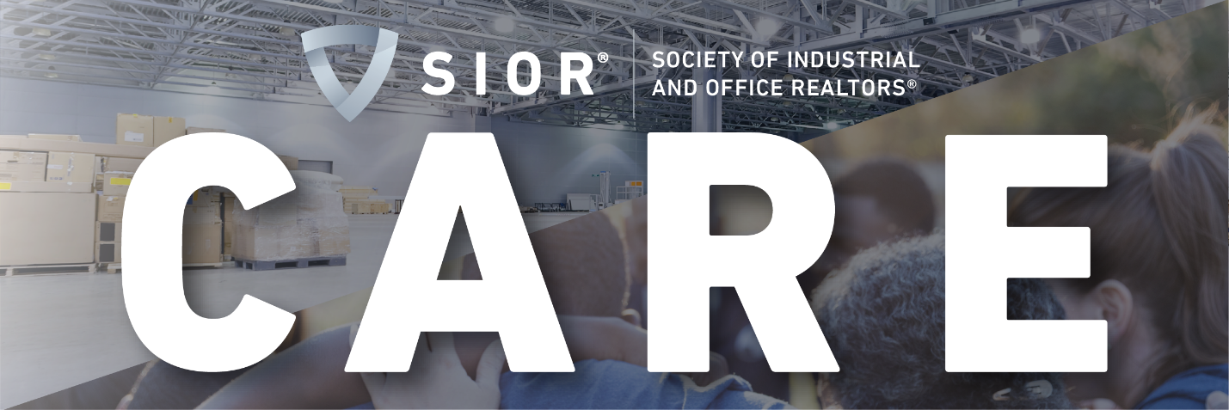

Do Your Part – Draft CARE Awareness Language for Local Outreach

Subject: New Community Relief Initiative to Provide Aid During COVID Pandemic

Message:

Good Morning/Afternoon NAME,

In these uncertain times, we all need to come together (collaboratively, not physically!). I’m reaching out to inform you of a new emergency relief program that could benefit many members of our community.

I am a member of the Society of Industrial and Office Realtors® (SIOR), which is made up of 3,400 elite commercial real estate brokers across the globe. SIOR is stepping up to support communities during the COVID-19 crisis by introducing the Community Assistance and Relief in Emergencies (CARE) program. Many organizations such as food banks, shelters, school food distribution centers, and emergency medical organizations, are in need of additional space to operate and meet the needs of their communities. Landlords and tenants also have questions about rent and resource needs. As experts in commercial real estate with unmatched connections locally, regionally and across the country and world, SIORs are uniquely positioned to find the space that these groups desperately need or offer expert guidance.

Organizations can quickly and easily reach out to SIOR via SIOR.COM/CARE and complete the short form to express their location and need. SIOR, as an organization, can engage the appropriate real estate professionals to get our community members the services and solutions they need.

Please help me spread the word throughout our community so we can offer our assistance. We look forward to utilizing our members’ skill sets for the benefit of our community.

You can find more information about the CARE program here.

Thanks, and Stay Safe!

[Your Signature]

